**PHASE -4:**

**A CRM Application to Manage the Services offered by an Institution**

Phase 4: Process Automation for EduConsultPro

**Step 1: Define Goal**

* Automate Student Application Status updates when Admission Application is created/updated.
* Reduce manual work, ensure real-time updates, minimize errors.

**Step 2: Create Record-Triggered Flow**

1. Setup → Flows → New Flow.
2. Select **Record-Triggered Flow** → Create.
3. Object: **Appointment**.
4. Trigger: **When a record is created**.
5. Add **Action Element** → Select **Submit for Approval** → Label: "Approval SubFlow".
6. Set **RecordId = {!$Record.Id}**.  
   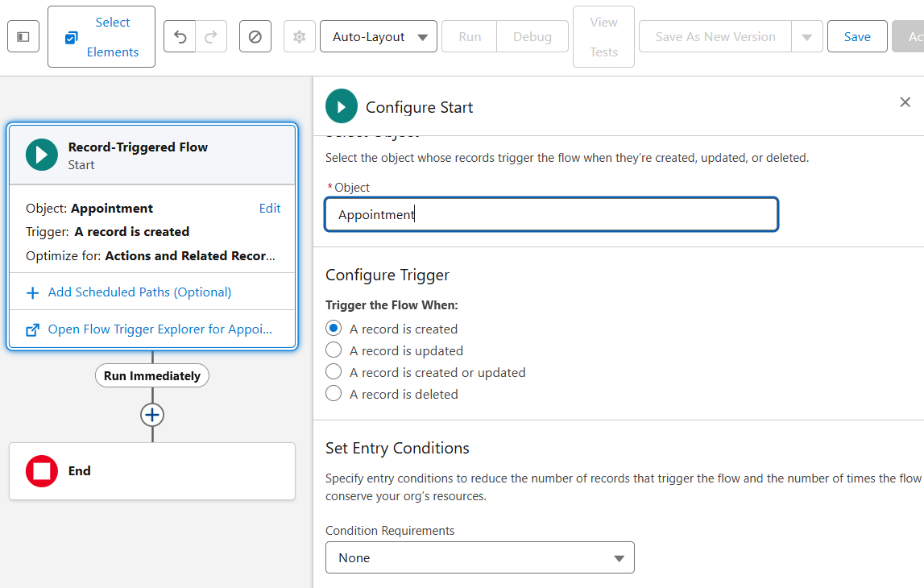  
   Action Element:  
   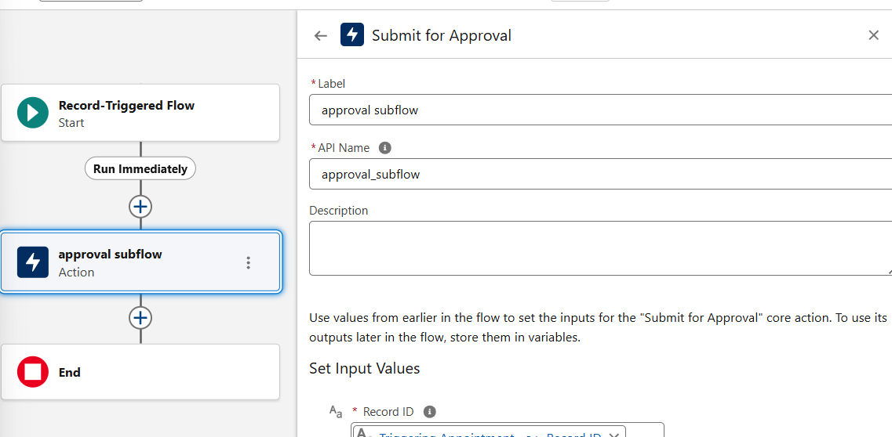

**Step 3: Screen Flow for Existing Student**

1. Setup → Flow Builder → New Flow → Screen Flow.  
   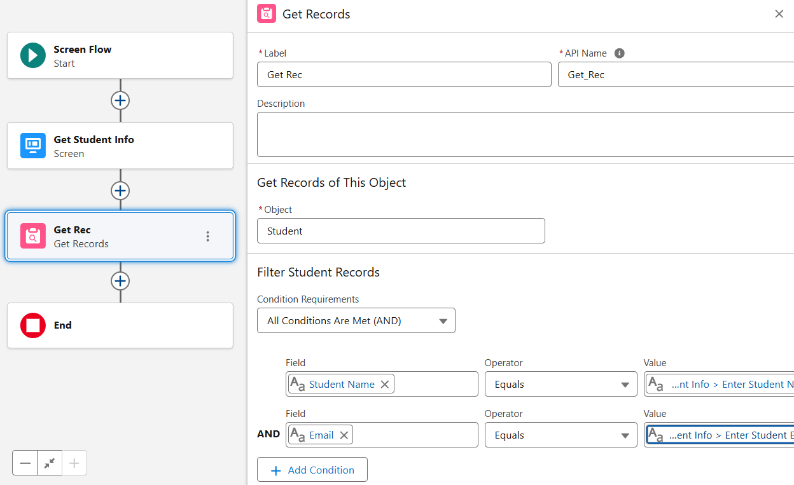
2. Add **Screen Element** → Label: "Get Student Info".
   * Add 2 Text Components → Labels: "Enter Student Name", "Enter Student Email".

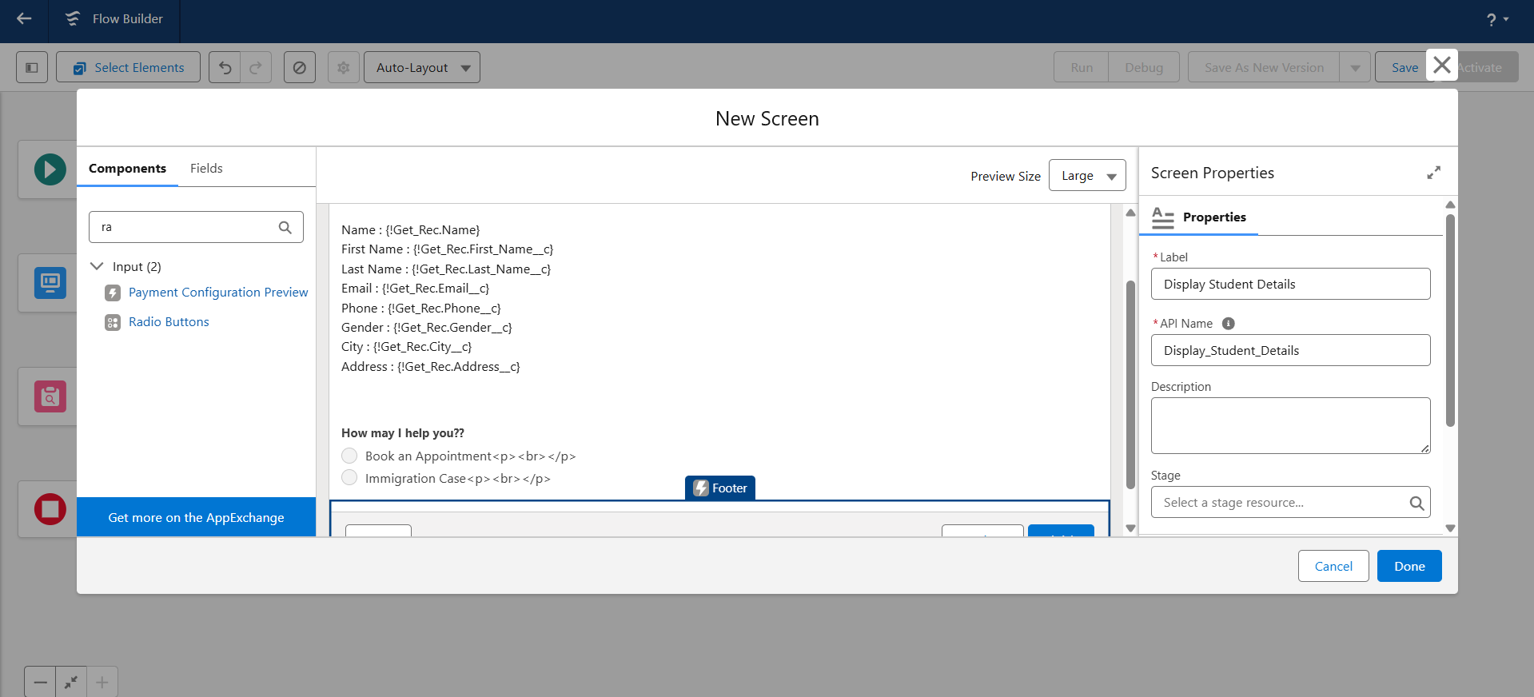

1. Add **Get Record Element** → Label: "Get Rec".
   * Object: **Student**.
   * Conditions: Student Name = {!Enter_Student_Name}, Email__c = {!Enter_Student_Email}.
2. Add **Screen Element** → Label: "Display Student Details".
   * Display Text with Student fields (Name, Email, Phone, etc.).
   * Add **Radio Buttons** → Label: "How may I help you?"
   * Create Choices: "Book an Appointment", "Immigration Case".
3. Add **Decision Element** → Label: "Appointment or Case?"
   * Outcome 1: Appointment → {!How_may_I_Help_you} = {!Book_an_Appointment}.
   * Outcome 2: Case → {!How_may_I_Help_you} = {!Immigration_Case}.  
     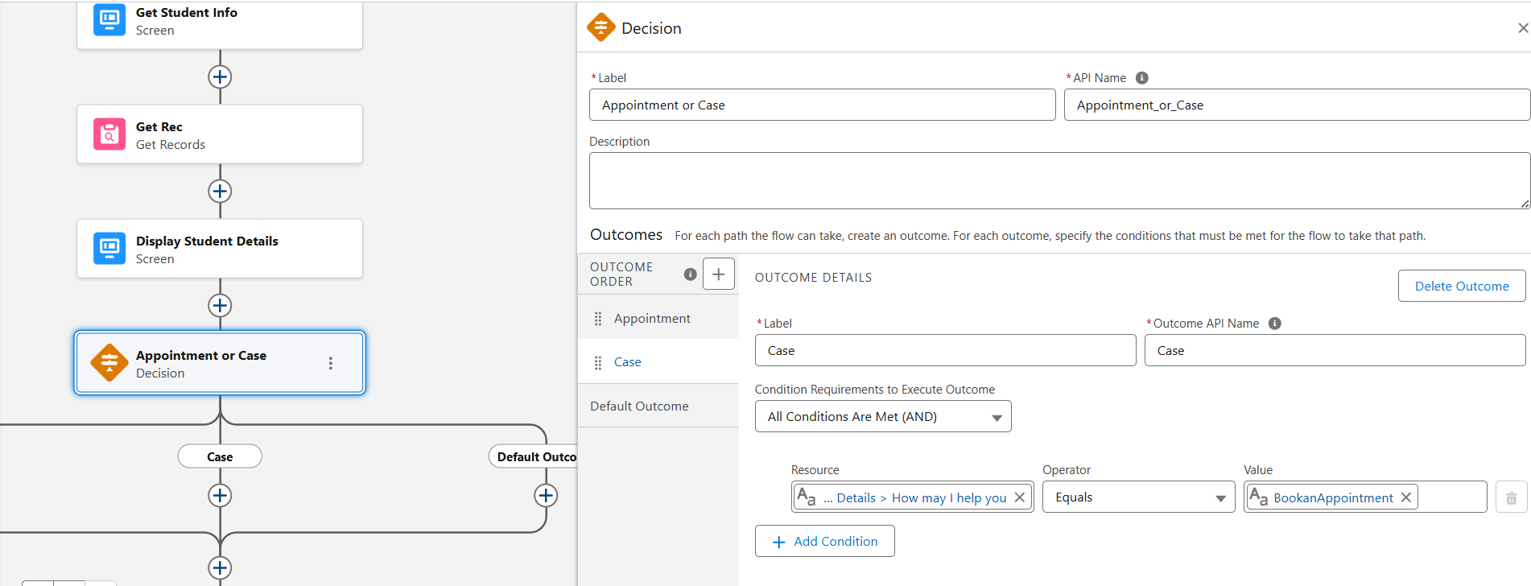

**Step 4: Check Application Status**

1. Add **Decision Element** → Label: "Check Status".
   * Outcome 1: Approved → {$Record.Status__c} = "Approved".
   * Outcome 2: Rejected → {$Record.Status__c} = "Rejected".
   * Outcome 3: Default → Pending/Other.  
     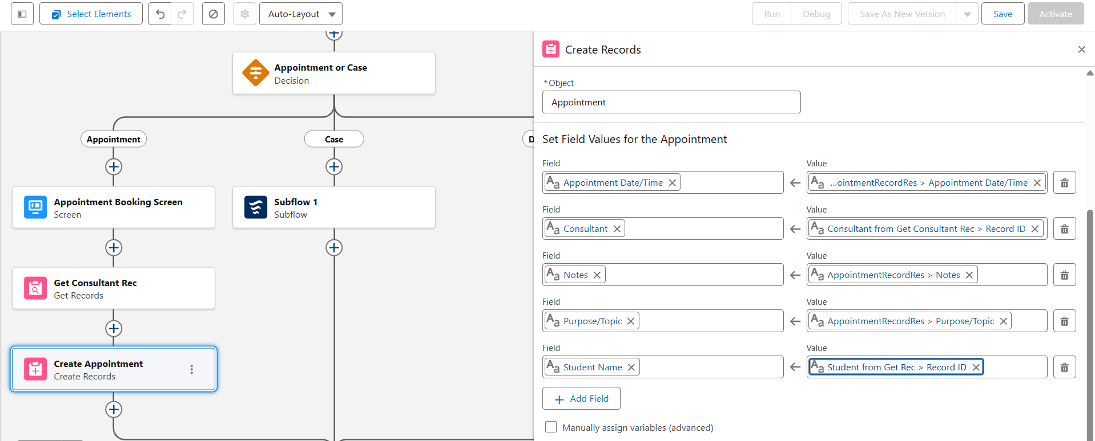

**Step 5: Create Email Templates**

1. Setup → Templates → Lightning Email Template (ON).
2. Create Folder → Create New Template.
3. Add **Submission Template** (confirmation email).
4. Create **Approval Template**.
5. Create **Rejection Template**.  
   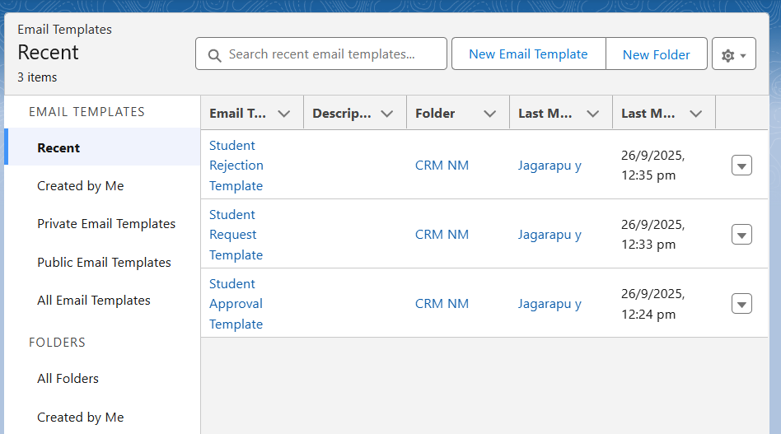

**Step 6: Create Approval Process**

1. Setup → Approval Processes → Appointment → New → Jump Start Wizard.
2. Process Name: **Appointment Approval**.
3. Select Approver → **Manager**.
4. Record Editability: **Admins/Assigned Approver**.
5. Save.
6. Configure Actions:
   * **Initial Submission Actions**:
     + Field Update → Status = Pending.
     + Email Alert → Submission Email Template.
   * **Final Approval Actions**:
     + Field Update → Status = Approved.
     + Email Alert → Approval Template.
   * **Final Rejection Actions**:
     + Field Update → Status = Rejected.
     + Email Alert → Rejection Template.

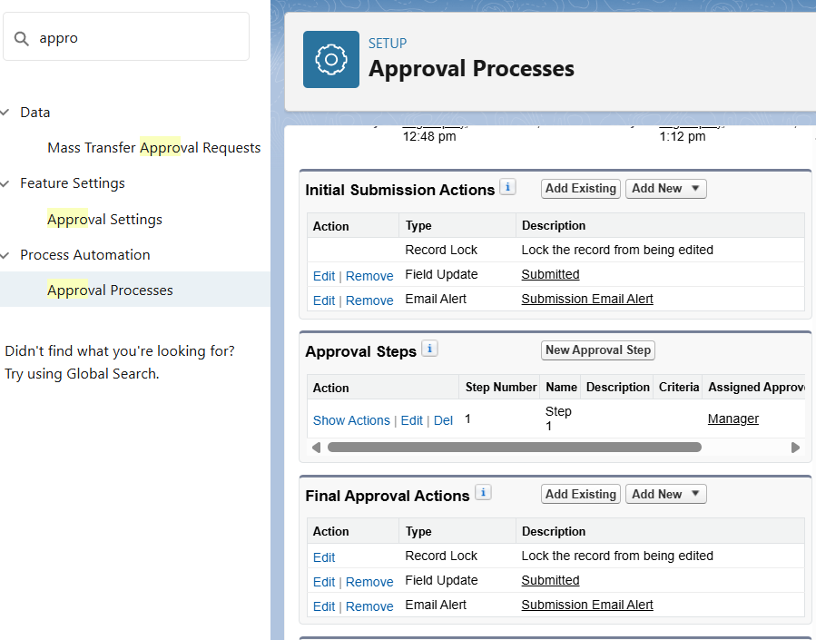

**Step 7: Update Student Status**

1. Add **Update Records Element** → Label: "Update_Student_Status".
2. Record: Student (from Get_Student).
3. Field: Status__c → Value: Approved / Rejected / Pending (based on Decision).

**Step 8: Connect Flow Elements**

* Start → Get_Student → Check Status → Update_Student_Status → End.
* Connect Approved, Rejected, Default paths.

**Step 9: Save & Activate Flow**

• **Flow Label:** EduConsultantPro Existing Student Flow

• **API Name:** EduConsultantPro_Existing_Student_Flow

• **Description:** Automatically updates Student__c status based on AdmissionApplication__c status when the record is created/updated.

Save → Activate.

